import java.util.Scanner;

class account

{

String n,add,type;

int ac_n;

double i_amt, c_amt;

account(String nm, int a_n, double i_a)

{

n=nm;

ac_n=a_n;

i_amt=i_a;

}

account(String nm, int a_n, String a, String t, double i_b)

{

n=nm;

add=a;

type=t;

ac_n=a_n;

i_amt = i_b;

}

void Deposit(double b)

{

c_amt=i_amt+b;

}

void Withdraw(double b)

{

c_amt=c_amt-b;

}

double Get_Balance()

{

return c_amt;

}

void display()

{

System.out.println(" ACCOUNT DETAILS");

System.out.println("Name : "+n);

System.out.println("Account No : "+ac_n);

System.out.println("Address : "+add);

System.out.println("Type : "+type);

System.out.println("Initial Balance : "+i_amt);

System.out.println("Current Balance : "+ Get_Balance());

}

public static void main(String arg[])

{

Scanner sc=new Scanner (System.in);

String name,addr,ty;

int an;

double ia,d,w;

System.out.println("Enter name, account number, initial amount :");

name=sc.nextLine();

an= sc.nextInt();

ia= sc.nextDouble();

account a1 = new account(name,an,ia);

a1.add="Ranchi";

a1.type="Savings";

System.out.println("Enter amount to deposit and withdraw :");

d= sc.nextDouble();

w= sc.nextDouble();

a1.Deposit(d);

a1.Withdraw(w);

a1.display();

System.out.println("Enter name, account number, address, initial amount, type :");

name=sc.next();

an= sc.nextInt();

ia= sc.nextDouble();

addr= sc.next();

ty= sc.next();

System.out.println("Enter amount to deposit and withdraw :");

d= sc.nextDouble();

w= sc.nextDouble();

account a2= new account(name,an,addr,ty,ia);

a2.Deposit(d);

a2.Withdraw(w);

a2.display();

}

}

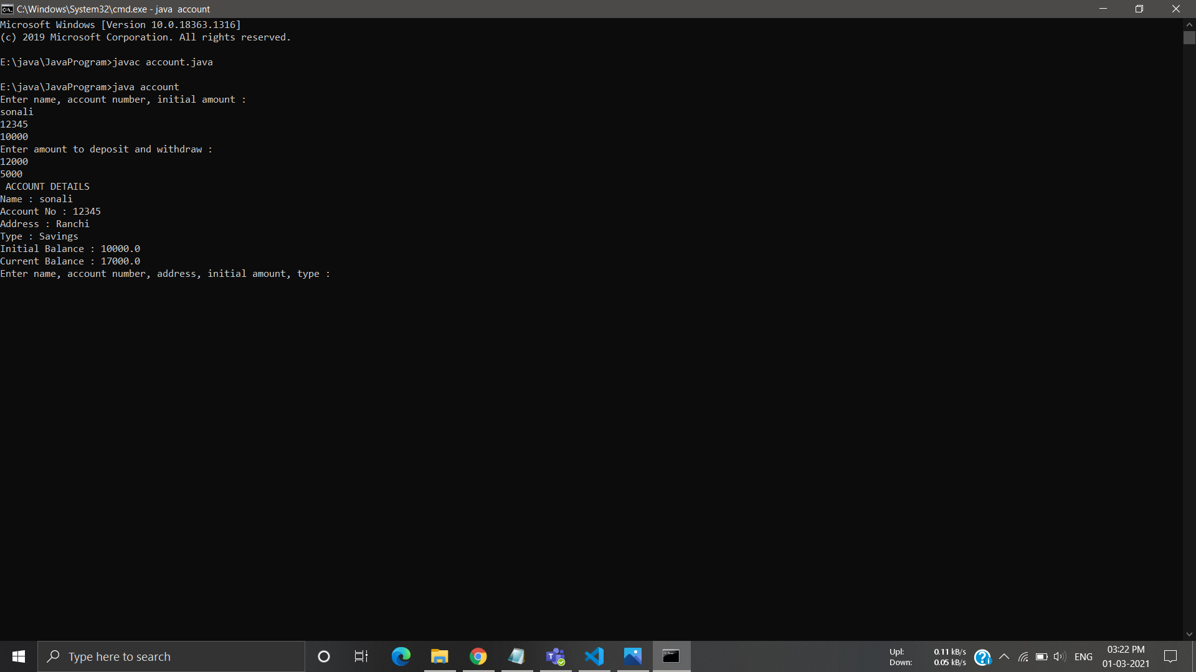

import java.util.Scanner;

public class timee {

public static void main(String[] args) {

Clock clock1 = new Clock();

Clock clock2 = new Clock(1, false);

Clock clock3 = new Clock(1, 10, 59, true);

clock1.getHours();

clock2.getIsAM();

clock3.getMinutes();

clock1.getSeconds();

}

}

class Clock{

private int Hours;

private int Minutes;

private int Seconds;

private String period;

Clock(){

Hours = 12;

Minutes = 0;

Seconds = 0;

period = "am";

}

Clock(int hour, Boolean isAM){

if(isAM){

period = "am";

}else{

period = "pm";

}

Hours = hour;

Minutes = 0;

Seconds = 0;

}

Clock(int hour, int minute, int sec, Boolean isAM){

if(isAM){

period = "am";

}else{

period = "pm";

}

Hours = hour;

Minutes = minute;

Seconds = sec;

}

void getHours(){

System.out.println(Hours);

}

void getIsAM(){

System.out.println(period);

}

void getMinutes(){

System.out.println(Minutes);

}

void getSeconds(){

System.out.println(Seconds);

}

}

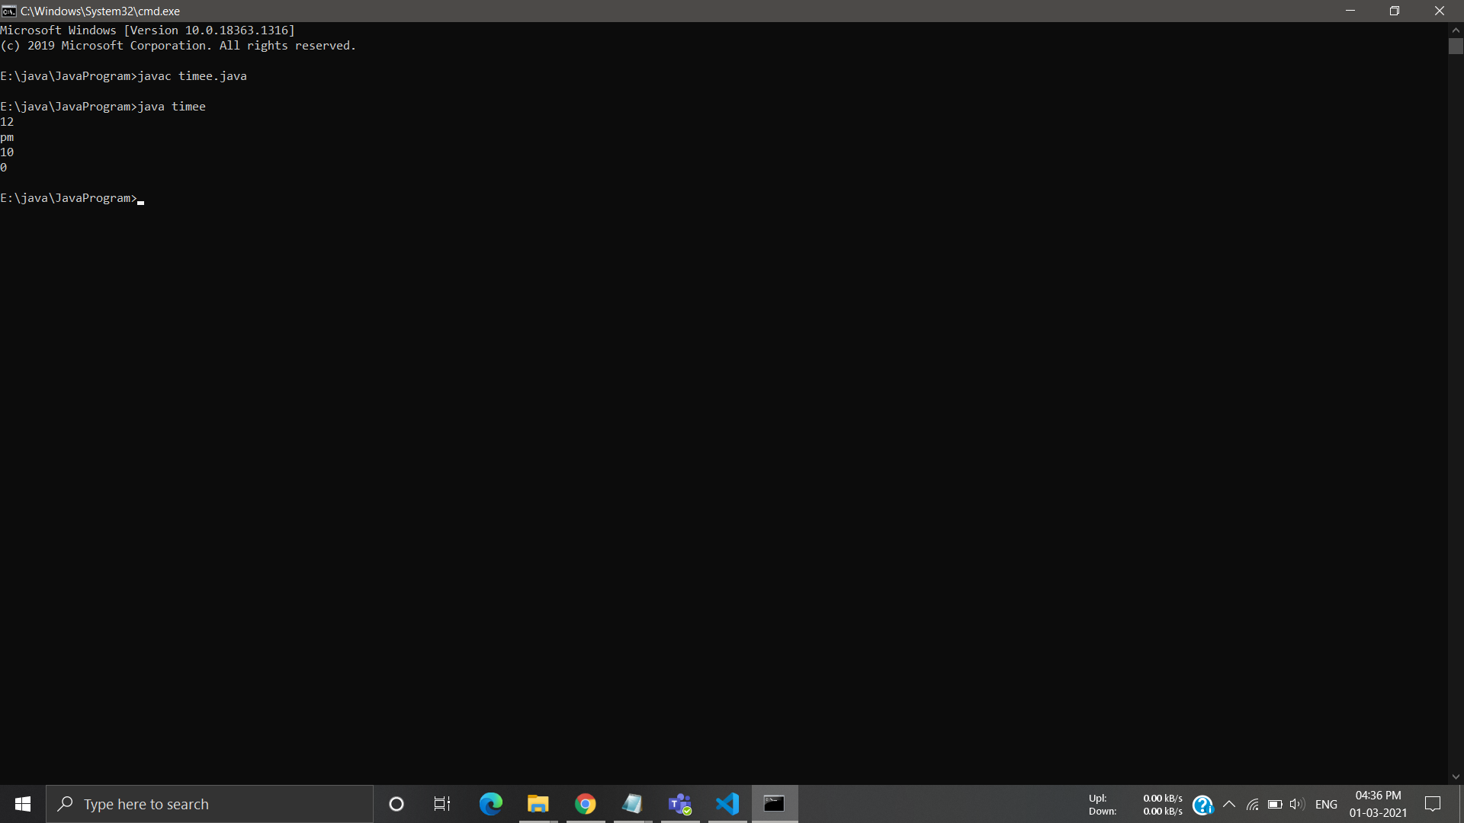

import java.util.Scanner;

class distance

{

String n[]={"Bokaro","Deoghar","Hazaribagh","Jamshedpur","Kolkata","Lucknow","Mumbai","Nagpur","Purulia"};

int d[]={180,250,90,140,400,740,1500,870,130};

int index=-1;

void find(String city)

{

int low=0,high=8,mid;

while(low<=high)

{

mid=(low+high)/2;

if(n[mid].compareTo(city)==0)

{

index=mid;

break;

}

else if(n[mid].compareTo(city)>0)

{

high=mid-1;

}

else

low=mid+1;

}

}

void display(String city)

{

if(index>=0)

System.out.println("Distance of " +city+ " from Ranchi is " +d[index] +" km");

else

System.out.println("Distance not found");

}

public static void main(String arg[])

{

distance obj=new distance();

String c;

Scanner sc=new Scanner(System.in);

System.out.print("Enter City :");

c=sc.next();

obj.find(c);

obj.display(c);

}

}

